BRIDGE TE AROHA: lovely place, lovely game ♠♥♦♣
Te Aroha News February 2024
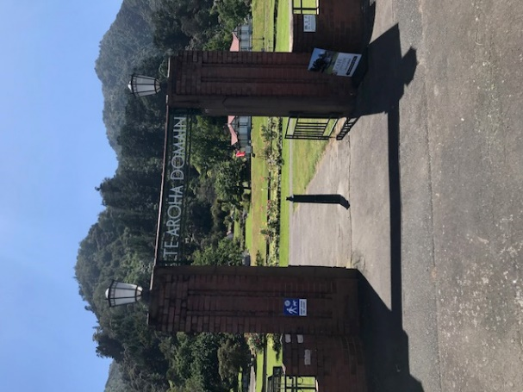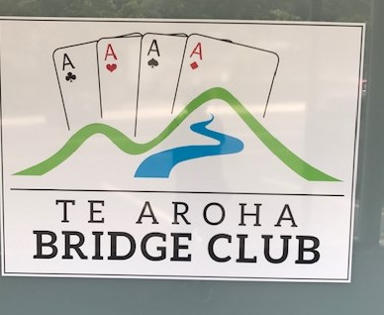
Farewell Hermanna
Saturday 24th February was a very sad day for all members of the Te Aroha and Matamata Bridge Club and also for the Kalma and Hemmes families. We have lost a member who has meant such a lot to both bridge clubs. At Te Aroha, Hermanna was honoured with the award of Life Membership in November 2022. She loved bridge, a game she came to relatively late in life. That love has helped this club to survive and now to prosper. We all owe Hermanna a big “thank you”.
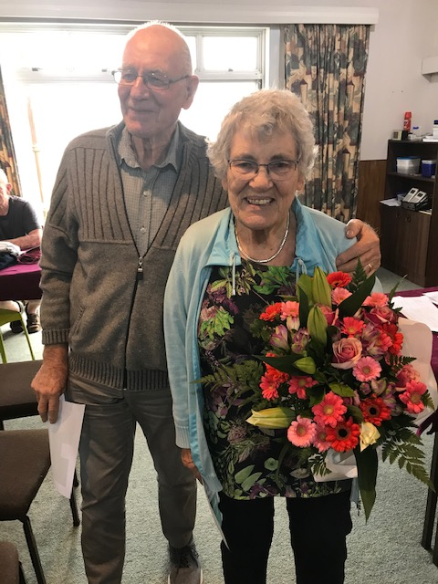
In her honour, I would like to reprint the story I wrote two years ago, just before Hermanna turned 80. I have made a few amendments to what was written originally, in keeping with her passing. The story finishes with a bridge hand Hermanna played only last week.
“Now, if you played a game five times every week plus the occasional tournament at weekends, then that game has just got to be very important in your life. That would certainly be true when referring to the game of Bridge in the life of Hermanna.
Yet, as well as Bridge being important to Hermanna, Hermanna has for very many years been important to Bridge with particular reference to Te Aroha and Matamata Bridge Clubs, not just for her own contribution but the contribution made by her family, the Kalma’s.
Hermanna just loves the game. There was disappointment written all over her face when she told me during a chat with her that there was no bridge at the club the following day because it was Good Friday! I was engaging Hermanna and Henk in conversation because she was soon to reach 80.
I wanted to find out about how Hermanna got into Bridge and what her roles had been for her two bridge clubs. So, with some help from her bridge-playing children (naturally, they all play!), this is her story.
She came to New Zealand, initially to the Cambridge area, in 1965, from Friesland, and has not strayed too far ever since. However, bridge entered her life first of all in 1988 when she went back visiting family in Friesland. She was greeted by her father who told her she should learn the game. However, it was not until 1991 that she went along to the Te Aroha club for lessons. There were only two learners at the club that year, Malcolm Kirkby and Hermanna. 100% retention…that’s excellent!
In those days, Hermanna described Te Aroha as a very competitive club while there was a more relaxed atmosphere at her other club, Matamata. Back then, there were two evening sessions at the Te Aroha Club, Tuesdays and Thursdays but numbers were on the decline and there soon was just the one night. Hermanna did not play that much then but the partnership steward phoned her to see if she would come to the club to play with Henk who needed a partner: quite a good idea!
She herself soon became the partnership steward and a very active one too. She encouraged the likes of Laurie Belfield, Ross Stewart, Joan Derby-Smith and George Sherrell to come and play at the club. Anna commented that in its darkest low membership and table number days, the club would have folded but for the enthusiasm of the partnership steward, Hermanna. A few such new players made a big difference to a very small club…and of course, other than George, they are still active members.
In 2009, Hermanna became President of the Matamata Club, a position she held for three years. For several years, Hermanna organised a New Year’s Eve individual at the club. When the club were a couple short for a teams’ competition, Hermanna came to the rescue by roping in Guy and Anna. Guy had learnt the basics a few years before while Anna was not just thrown into the deep end of playing but was the hastily appointed scorer, as the club had its own bridgemates. She knew little about playing and even less about scoring!
Anna was to take over from her mother as partnership steward at Te Aroha. Meanwhile, one of the even younger generation, Jacob, learnt the game at the age of 12 and a few years later, Jacob’s father, Foster, learnt the game too.
So, we had Hermanna, her husband Henk, her three children, Anna, Guy and Foster, her grandson Jacob, and her sister Jel By de Ly (a former Katikati player) all playing. Meanwhile, Hermanna’s other 2 sisters played in Friesland.
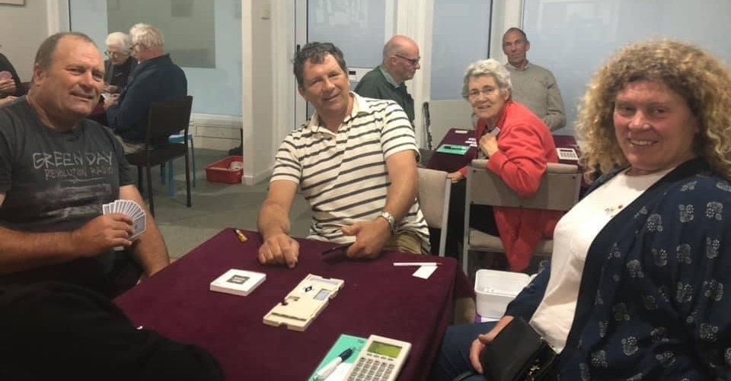
A mother and her three children. Other than on the farm, where else would they be?
More recently, Anna’s daughter, Greta, has been playing and last year, Foster’s wife, Karen, and daughter, Grace, came through the club’s beginners’ class and are now active members. That is a lot of Kalmas and other than Jacob and her late sister, Jel, they all play regularly at the Te Aroha Club.
Hermanna and Henk play affably together though she told the story of how at her sisters’ club in the Netherlands, there were two wives who played together as did their husbands. Apparently, the wives’ partnership has lasted 52 years but the two men’s partnership lasted just one week! No further words need be said.
Hermanna and Henk play both together and apart. Although they met at the Te Aroha Club, they knew each other elsewhere both from Henk’s Power Board job and in his later retirement years as a postman, including delivery to the Kalma household! Henk and Hermanna married in 2008.
Bridge was also a vehicle for holidays for Henk and Hermanna like at the Chateau on a bridge holiday organised by Johnny Lenart or on a number of bridge cruises and other holidays organised by Ron Klinger.
Hermanna’s commitment to the club was also shown more recently when the building of the new toilets meant no bridge could be played in the clubrooms for a while. You do not need two guesses to know in whose house the Friday daytime bridge was played.
We now have a thriving club in Te Aroha but for a few years, it looked like there would be no bridge club here at all. The club’s survival was in no small way down to the commitment and enthusiasm of both Hermanna and in later years of Anna.”
Bridge has been a major part of Hermanna’s life in the last 35 years. In introducing the game to her children and other relatives, she performed a wonderful service to the Te Aroha Bridge Club and ultimately ensured its survival during its darkest period. For her services to the club, in November 2022, along with Henk, she was made a Life Member of the club.
I have only been playing at the club for 2 and a half years. It is a wonderful experience going along every Tuesday. Hermanna has always been there, maybe a little late to arrive (well, on time!) but we always knew she and Henk were coming. There were two very engaging sides to Hermanna that I admired. One was her smile. The other was her determination at all costs to make or defeat a contract. We all know she loved playing in 3NT and I rather dreaded it when I was defending that contract against her. The smile disappeared but the determination and the ability did not.
We also know that she played her last session at the club only one day before she died. She and Henk came equal fourth with 53.47%. It would have been neat to report that she bid and made 3NT on her last hand. That was only half true:
Board 12  West Deals  N-S Vul | ♠ A Q 7 3  ♥ J 10  ♦ K Q 10 6 5  ♣ K 9
♠ 9 6 5 4  ♥ 9 8 2  ♦ 8 7  ♣ A 5 4 2 | N  W E  S | ♠ K J 2  ♥ K 7 5 4  ♦ A  ♣ Q 10 8 6 3
♠ | 10 8
♥ | A Q 6 3
♦ | J 9 4 3 2
♣ | J 7

West | North | East | South
 | Henk |  | Hermanna
Pass | 1 ♦ | Pass | 1 ♥
Pass | 1 ♠ | Pass | 1 NT
All pass

West led S6. Hermanna played low from dummy with East’s SJ winning. East tried a club switch to West’s CA. West continued a second club. Hermanna won to play three more rounds of diamonds, staying in the North hand. Next HJ which East covered. Hermanna still had a high diamond in her hand and could take 3 heart tricks, 4 diamond tricks, SA and CK, 9 in all. That would be a nice result if one was in game though with 23 combined hcp, part-score is where you want to be.
She had made one trick more than she was entitled to do, as she so often did.
We will all miss you, Hermanna, and are so grateful for what you have done for this club.
Hermanna’s funeral takes place at the Morrinsville Baptist Church at 11am on Monday March 4th.
Back on the Board
As most of you know, our club has been represented on the Board of New Zealand Bridge for the last three years. Anna has brought her considerable marketing experience to the Board as well as in particular to the Board’s Teaching Committee and also to the National Congress Sub-Committee. After three years, Board Members automatically retire but are eligible for re-election and as of 1st April this year, Anna has been re-elected unopposed. Congratulations, Anna. She may focus on bridge around the country but she retains a huge passion for the Te Aroha Club and helps out and plays there whenever she can.
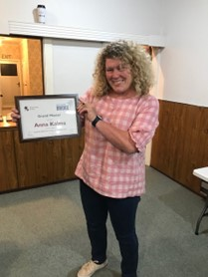
Anna being presented with her Grand Master certificate, very appropriately at the Te Aroha Club.
And at the bridge table, too!
Talking of Anna, she, along with yours truly, will be taking part in the trial to select a Mixed Team to take part in the World Championships in Buenos Aires which take place in late October this year. Anna and I and our teammates, Hamish Brown and Johanna Perfect, are not expecting to win (for my three teammates, it will be their first experience of National Trials). You can follow our progress over this coming weekend. The event is live at the Auckland Bridge Club and there are 4 sessions of 14 boards each day. Each day is a knock-out match. So, we are hoping to be playing on more than one day! Session results will be published as they happen on the New Zealand Bridge website.
ProTag Swiss Pairs
Thanks once again to Charlotte and Tyrel for sponsoring this event, the first contested event of 2024. It is also pleasing to be able to report (now, I would say that whoever won but it especially nice to do so this time! ) that Ross McIntyre and his partner defended the title they won last year successfully.

Tim and Rochelle had a sizeable lead going into the third night though they struck Victor and Mark (a very able substitute for Peter Daffurn) in sparkling form and with one match to play, they trailed by about 1.Vp, a margin which increased to just over 4 vps by the close of play.
February Tip…from the Pro Tag Pairs
Since half the field missed this game on the final night of the Swiss Pairs, my tip for February is that if you or your partner opens 2C, then your partnership must go to game even if one of the hands is woefully weak. The following sequence occurred too often that evening:
South Deals  E-W Vul | ♠ 10 9 6 5  ♥ 7 6 5 2  ♦ J  ♣ 9 7 5 3
♠ 7  ♥ J 8 3  ♦ K 10 8 5 2  ♣ A K 10 8 | N  W E  S | ♠ J 4 2  ♥ K 10 9 4  ♦ 7 6  ♣ Q J 6 4
♠ | A K Q 8 3
♥ | A Q
♦ | A Q 9 4 3
♣ | 2

West | North | East | South
 |  |  | 2 ♣
Pass | 2 ♦ | Pass | 2 ♠
All pass
North felt that they were too weak to bid beyond 2S. If, as I think is best, that you play that 2C is forcing to some game, then the bidding will flow much more smoothly.
North, above, did too rather under-value their hand. With one diamond and 4 trumps, that North hand has a lot of potential and North should bid 4S, which, because the partnership is going to game, is weaker than a raise to 3S.
South should pass 4S and with average luck (the heart finesse worked but there was an unlucky diamond break), a declarer should make at least 10 tricks, 11 if the defence does not play a round of trumps.
Incidentally, do you remember my January tip? I will be asking you if you do! It said that third player should not always play high. Watch here. West would start with CA and their best play at trick 2 is the S7. If East plays SJ, they will never be able to over-ruff dummy on the third round of diamonds. They should anticipate that. There can be no gain in playing SJ at trick 2.
East must play low if they want to score their SJ.
So, two months’ tips in one deal! Remember. Game Force means playing in game not in part-score! Occasionally, game will be defeated but it is not a good idea to “take a pessimistic view” and pass because you have no honour cards. Recently, at a tournament, the West players held a 29 count! Imagine if that was what South had on today’s deal if North passed 2S. Keep bidding after a 2C opener, at least until the game level!

The Gold Coast
The great week at the Gold Coast Bridge Congress had a sober sad ending for the 8 Te Aroha players who went. They had generally a great time. In view of the sad ending, I will keep back some of the pictures and stories until March. However, here are two very happy occasions to conclude a sad issue:
The Shuttlecocks
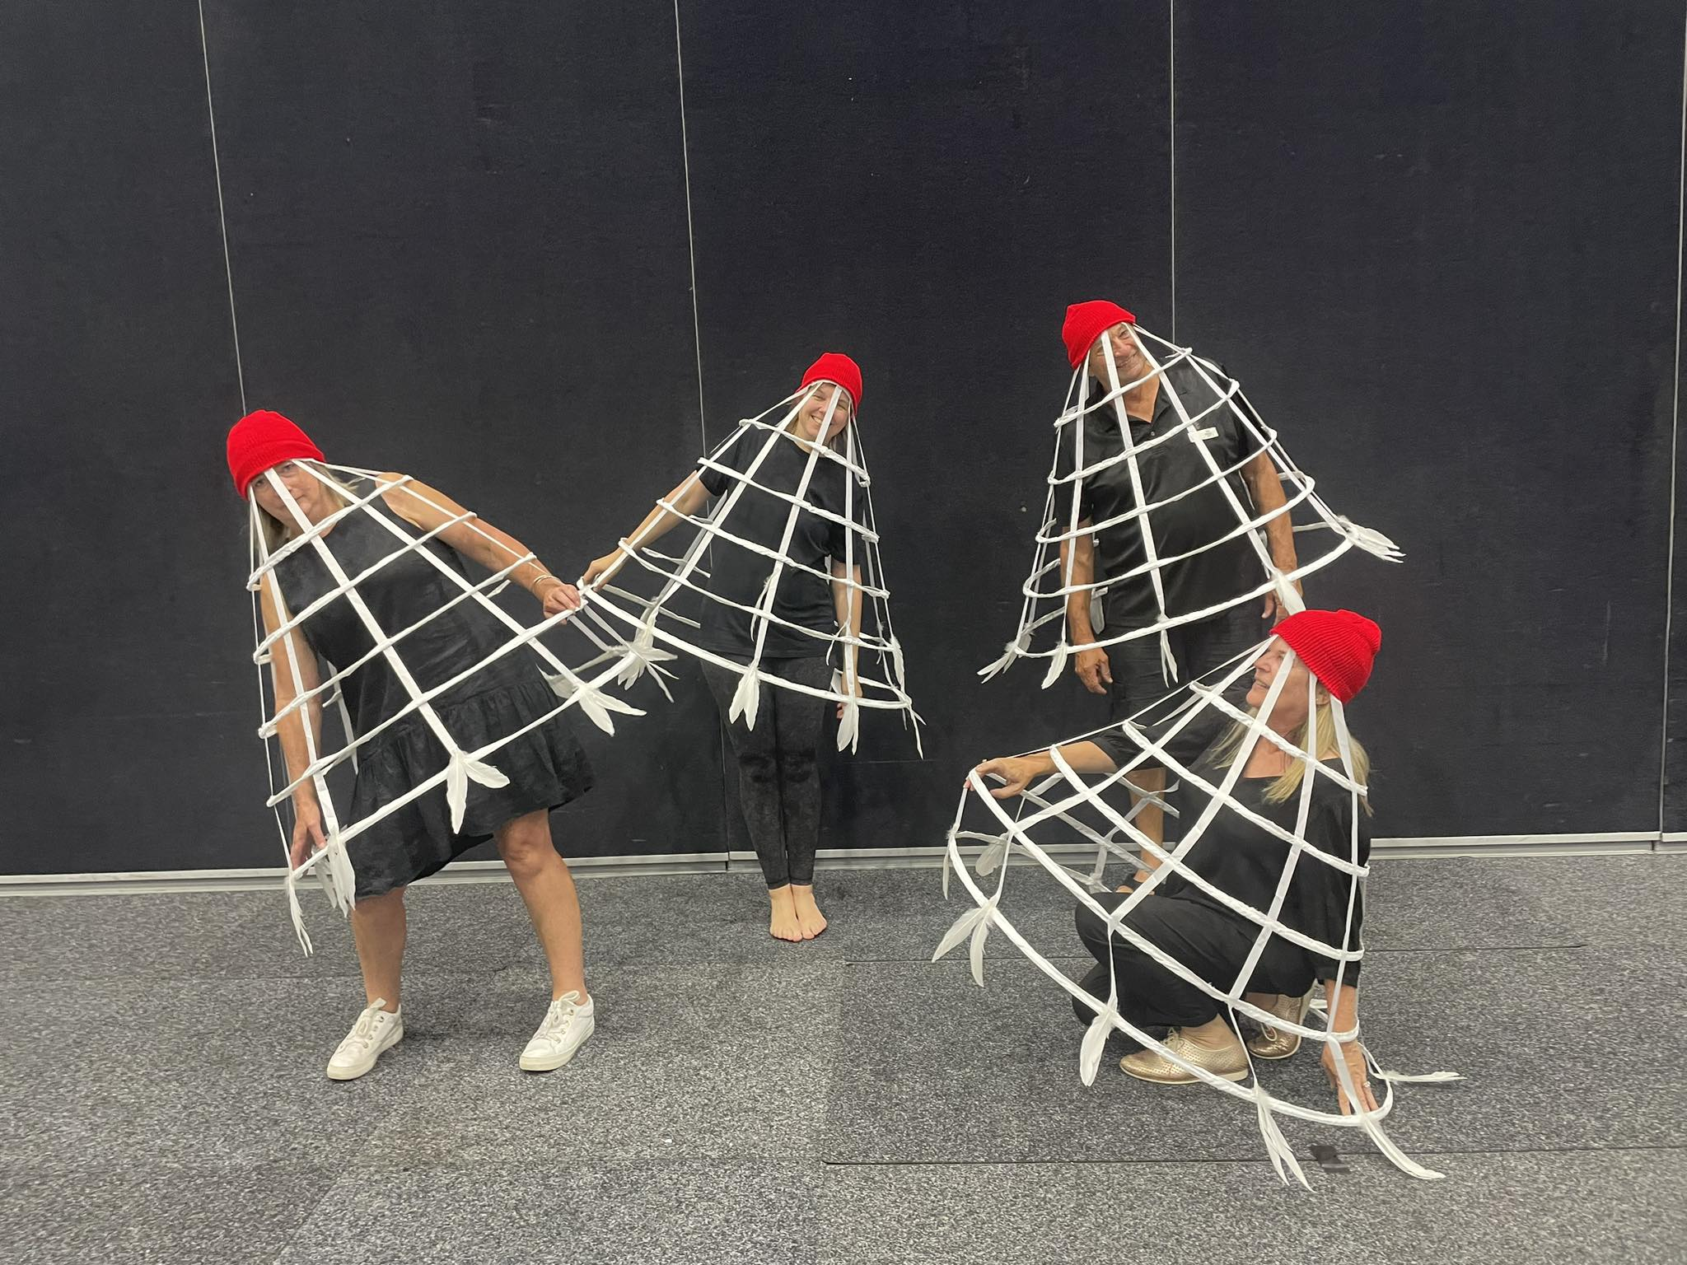
Te Aroha players are pretty good when it comes to the bridge but they are absolutely awesome when it comes to the Wednesday dress-up. The theme was sporting. Rumour has it that Te Aroha members win this dress-up so often that the wine prizes for first prize were delivered to Rochelle and Tim’s apartment days before the contest even took place.
They stayed there, too! First prize went to “The Shuttlecocks”. It was absolutely no contest. Now, you may (or maybe you are not) interested in who those 4 red-hatted individuals are. There are two full members of the club and two honorary ones who associated with the club for a week. Now, I can identify for certain a local farmer named Tim up at the top right. I also think we have a lady of the land on the left. She goes by the name of Rochelle.
The others sported Te Aroha Gold Coast sweatshirts during the week and are just dying to travel down from Mt Albert to Te Aroha for a game. They are certainly coming for the Spa Town Teams. They go by the names of Bigi and Emma. Certainly convertees to Te Aroha.
They all look just great…and the rest of the Te Aroha contingent, which included Rochelle’s husband, Honk, and Joy’s husband, Gary, and other Kiwis who wore the right shirts, were delighted to help them drink some of that wine: so well deserved.
There are two bridge hands all local players need to discuss with Tim, Rochelle too if you like. One is a fantastic 7 count with 5 diamonds and no particularly good shape. What would you do with that hand when your right-hand opponent opens 1H? Tim may be able to help you with some great advice.
This is the other:

South Deals  Both Vul | ♠ A 9 6 4 3 2  ♥ K  ♦ 9  ♣ A K 9 5 3
♠ K 10  ♥ Q J 9  ♦ K 6 3 2  ♣ Q J 8 7 | N  W E  S

West | North | East | South
you | dummy
 |  |  | 1 ♠
Pass | 2 ♣ | Pass | 2 NT
Pass | 4 NT | Pass | 5 ♠
Pass | 7 ♠ | All pass

The bidding was fast, furious (very “furious” if it did not have a happy ending) and not entirely accurate.
There was some doubt at the table as to which suit was trumps in the key-card 4NT ask. North, Rochelle, thought it was clubs and that Tim owned up to holding 2 key cards with his 5S response (both red aces and CQ!). Tim, South, was fixed on spades being the suit and showed both red aces and the SQ!
As Tim had opened 1S, at least 5 spades, Rochelle was not worried whether or not Tim held SK) as they had at least 11 spades between them. Hence, she bid 7S.
As you can see from the West hand, there was an important card missing in 7S…SK.
As West, you led CQ and Tim thanked Rochelle very much for her dummy. Just what he was looking for…. well, maybe not! He won the CA in dummy and played D9 to his own DA.
Next came SQ from his hand. Tim and Rochelle open 5-card majors. It is your play as West.
Have you played yet? Which spade do you play? I repeat: your opponents are playing 5 card majors.
There were 2 considerations for you as West:

South Deals  Both Vul | ♠ A 9 6 4 3 2  ♥ K  ♦ 9  ♣ A K 9 5 3
♠ K 10  ♥ Q J 9  ♦ K 6 3 2  ♣ Q J 8 7 | N  W E  S | ♠ —  ♥ 8 6 5 4 3 2  ♦ J 10 7 5 4  ♣ 4 2
♠ | Q J 8 7 5
♥ | A 10 7
♦ | A Q 8
♣ | 10 6

West | North | East | South
 | Rochelle |  | A relieved declarer!
 |  |  | 1 ♠
Pass | 2 ♣ | Pass | 2 NT
Pass | 4 NT | Pass | 5 ♠
Pass | 7 ♠ | All pass
Do you remember the key rule about whether you cover an honour with an honour?
You only do so if it will or could benefit your side!
The other guideline is if you do not cover the honour, you should do so without hesitating or else the declarer will conclude you do hold that card.
The Australian West had not heard of the first rule. They covered the SQ with their king, without hesitating! They knew their partner held no spades from Tim’s opening bid. There could be no gain in covering except reducing declarer’s stress level.
Heroes were our North/South pair as only a couple of other pairs at the Coast bid and made grand slam: that’s out of some 1100 pairs!
I believe had West played a smooth S10, Tim could still be at the table deciding whether or not to finesse.
More news from the Gold Coast in March. In the meantime, I am sure all at the club mourn the loss of one of its most respected members.
Richard Solomon

